ASR 5986 Upload current inventory report to generate Storage type mapping report.

1. Import Current Inventory report downloaded from SAP
2. New report – Storage type Mapping Report

Source file:

Source file in Excel format:

Report template:

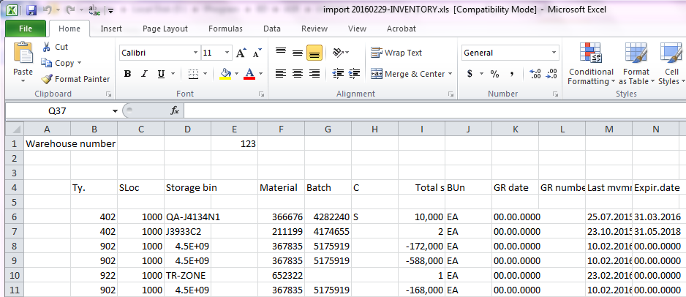

**WMS Changes:**

**Date 2016.03.08**

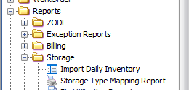

1. Import Daily Inventory - > system able to import current inventory from inventory report downloaded from SAP, system will refresh the data every new upload of data.

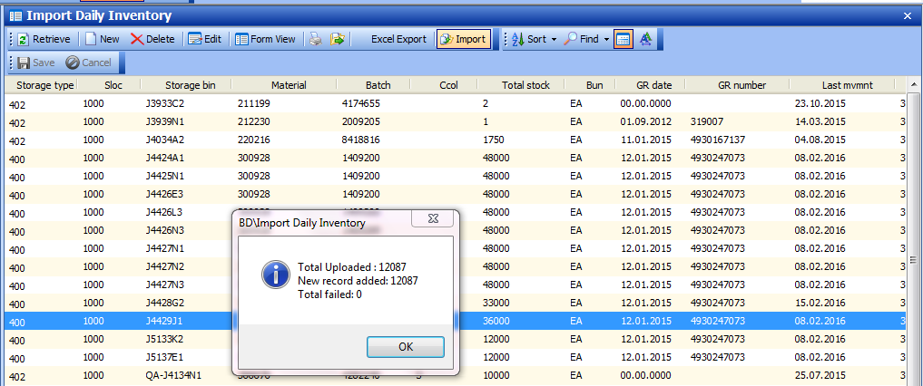

1. Storage Type mapping Report

Inventory report will mapped the bin Loc. Storage type vs SKU storage type.

Retrieve:

